**Postman screenshots: (ALL these are for user logged in )**

**User registered successfully:**

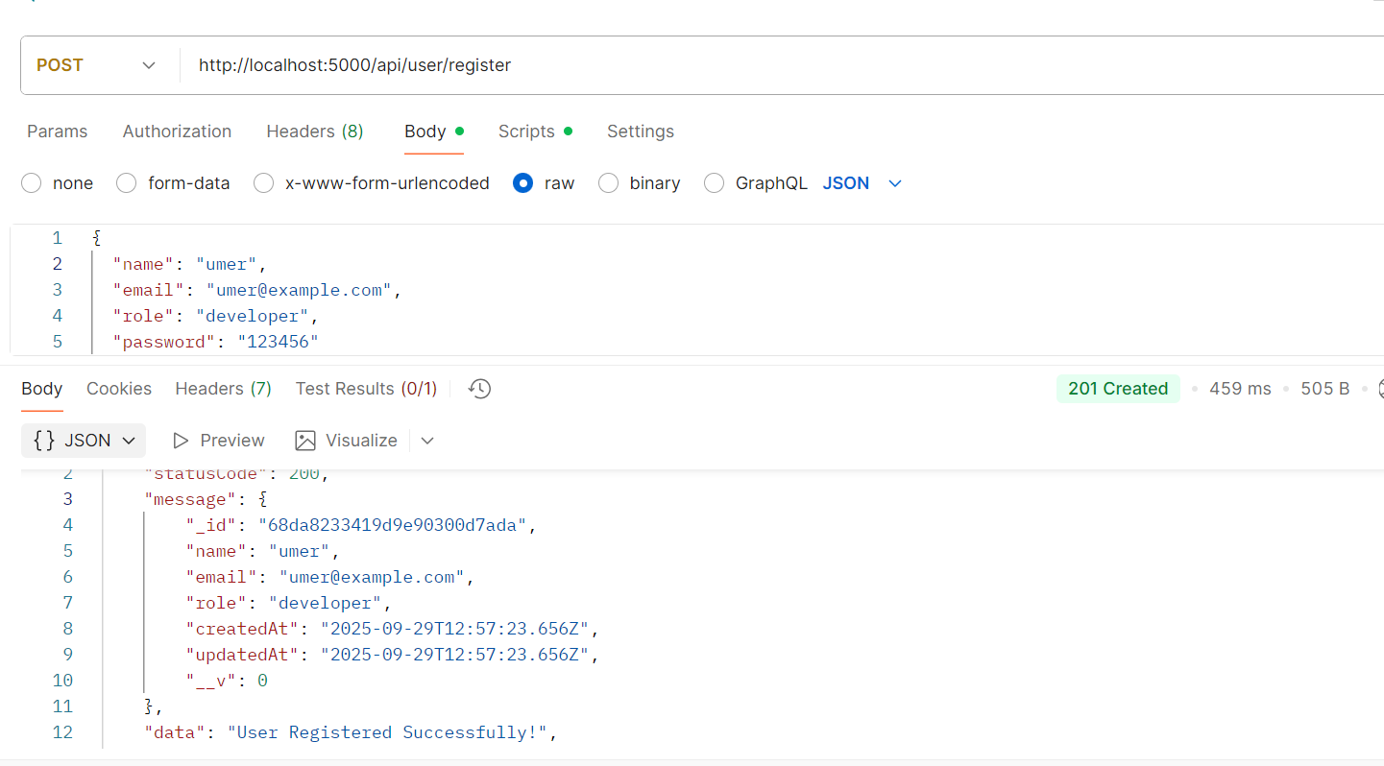

**Password using bcrypt:**

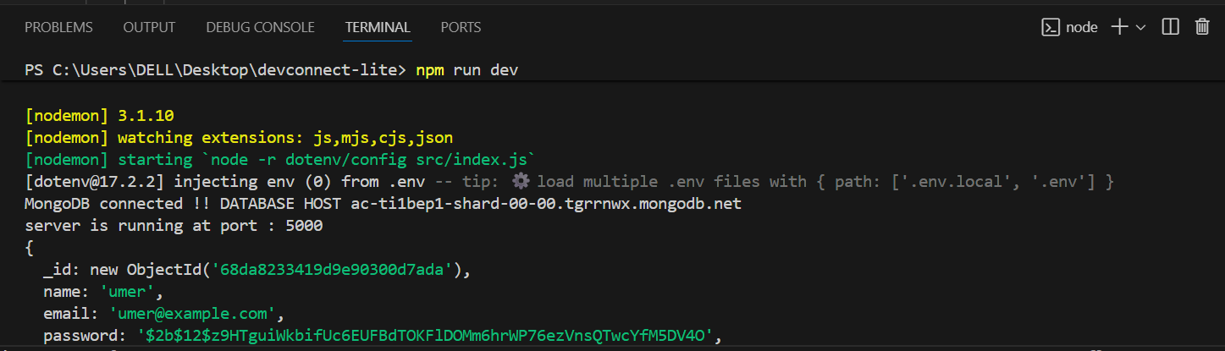

**Login based on email and password:**

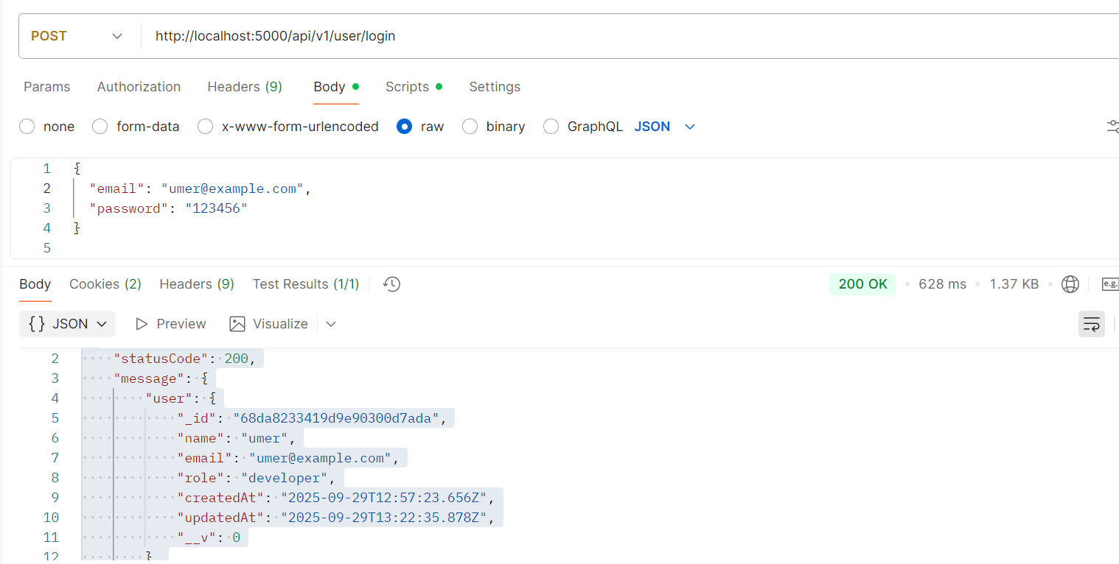

**Fetched user :**

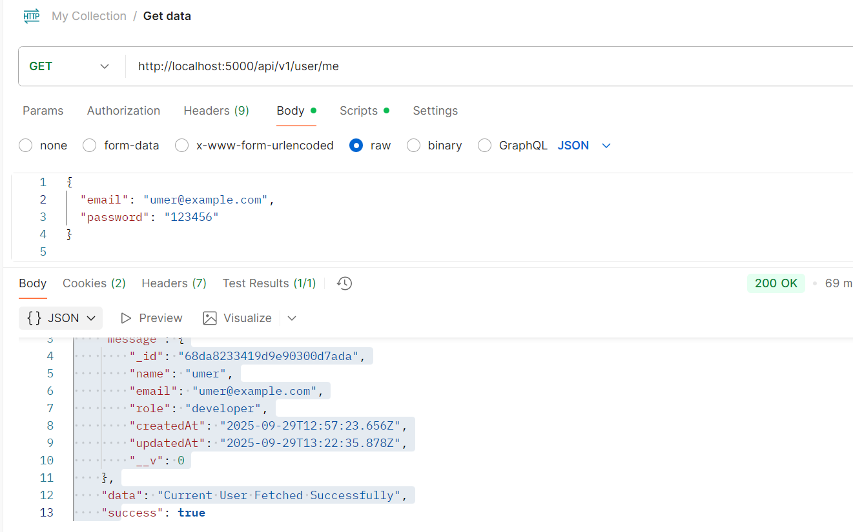

**Change password for user:**

**NOTE: PASSWORD IS NOT SHOWN TO YOU ALTHOUGH IT IS CHANGED**

**User Loggedout:**



